**LAB**

| **Use Case ID** | **Business Rule ID** | **Category** | **Business Rule Description** |
| --- | --- | --- | --- |
| UC-01 | BR-1 | Constraints | Email must be unique. |
| UC-01 | BR-2 | Constraints | Passwords must meet security standards. |
| UC-01 | BR-3 | Constraints | Users must agree to terms and conditions. |
| UC-02 | BR-4 | Constraints | Password is case-sensitive. |
| UC-02 | BR-5 | Constraints | Account lock after multiple failed attempts. |
| UC-03 | BR-6 | Constraints | Only active courses are shown. |
| UC-04 | BR-7 | Action Enablers | Session data is cleared after log-out. |

**UC-01: Register**

| UC ID and Name: | UC-01: Register | | |
| --- | --- | --- | --- |
| Created By: | Nguyễn Anh Tú |  |  |
| Primary Actor: | Guest |  |  |
| Trigger: | The guest clicks on the "Register" button on the website. | | |
| Description: | A guest creates a new account by providing their details and submitting the registration form | | |
| Preconditions: | PRE-1. The guest is on the website.  PRE-2. The registration page is available. | | |
| Postconditions: | POST-1. The guest becomes a registered user.  POST-2. The user receives a confirmation email. | | |
| Normal Flow: | NF-1. The guest clicks "Register."  NF-2. The system shows a form for the guest to enter their name, email, and password.  NF-3. The guest submits the form.  NF-4. The system checks the information.  NF-5. If all is correct, the system creates the account and sends a confirmation email.  NF-6. The system confirms redirect to login page. | | |
| Alternative Flows: | AF-4. Duplicate Email: The system shows an error if the email is already in use. | | |
| Exceptions: | E-4. System Error: If the system fails, an error message is shown. | | |
| Priority: | High | | |
| Frequency of Use: | Often | | |
| Business Rules: | 1. BR-1  2. BR-2  3. BR-3 | | |
| Other Information: | The confirmation email will include a link for email verification. | | |
| Assumptions: | The guest has a valid email address. | | |

**UC-02: Login**

| UC ID and Name: | UC-02: Login | | |
| --- | --- | --- | --- |
| Created By: | Nguyễn Anh Tú |  |  |
| Primary Actor: | User, Admin, Staff |  |  |
| Trigger: | The user clicks "Login" on the website. | | |
| Description: | A registered user, admin, or staff logs in by entering their email/username and password. | | |
| Preconditions: | PRE-1. The user has an account. | | |
| Postconditions: | POST-1. The user is logged in and redirected to their dashboard. | | |
| Normal Flow: | NF-1. The user enters their credentials and clicks "Login."  NF-2. The system verifies the credentials and logs the user in, redirect to Homepage. | | |
| Alternative Flows: | AF-1. Forgot Password: User clicks "Forgot Password" for recovery. | | |
| Exceptions: | E-2. Invalid Login: System shows an error for wrong credentials. | | |
| Priority: | High | | |
| Frequency of Use: | Very frequent | | |
| Business Rules: | 1. BR-4  2. BR-5 | | |
| Other Information: | None | | |
| Assumptions: | User knows their login details. | | |

**UC-03: Search course**

| UC ID and Name: | UC-03: Search course | | |
| --- | --- | --- | --- |
| Created By: | Nguyễn Anh Tú |  |  |
| Primary Actor: | Guest, User, Admin, Staff |  |  |
| Trigger: | The actor initiates a search for courses. | | |
| Description: | The actor searches for courses using keywords or filters. | | |
| Preconditions: | PRE-1. Courses are available in the system. | | |
| Postconditions: | POST-1. Relevant courses are displayed. | | |
| Normal Flow: | NF-1. Actor enters search criteria.  NF-2. System shows matching courses. | | |
| Alternative Flows: | AF-2. No results found. | | |
| Exceptions: | E-2. System error. | | |
| Priority: | Medium | | |
| Frequency of Use: | Frequent | | |
| Business Rules: | BR-6 | | |
| Other Information: | None | | |
| Assumptions: | Actor knows the search criteria. | | |

**UC-04: Log-out**

| UC ID and Name: | UC-04: Log-out | | |
| --- | --- | --- | --- |
| Created By: | Nguyễn Anh Tú |  |  |
| Primary Actor: | User, Admin, Staff |  |  |
| Trigger: | The actor clicks "Log-out." | | |
| Description: | The actor logs out of the system, ending the current session. | | |
| Preconditions: | PRE-1: The actor is logged into the system. | | |
| Postconditions: | The actor is logged out, and the session is terminated. | | |
| Normal Flow: | NF-1. The actor clicks the "Log-out" button.  NF-2. The system ends the session and redirects the actor to the homepage or login page. | | |
| Alternative Flows: | None. | | |
| Exceptions: | E-1. System Error: If the system fails to log out, an error message is shown. | | |
| Priority: | High | | |
| Frequency of Use: | Frequent | | |
| Business Rules: | BR-7 | | |
| Other Information: | None | | |
| Assumptions: | The actor wants to log out after finishing their tasks. | | |

## 1. Context diagram

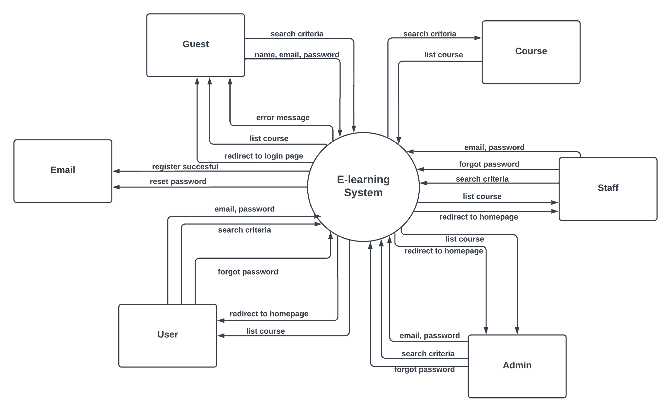

## 2. Swimlane

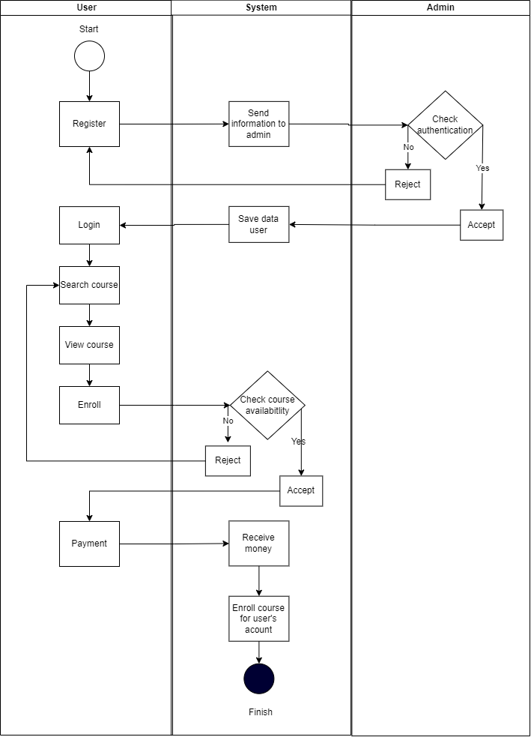

## 3. ERD

## 

## 

## 

## 

## 

## 

## 

## 4. State diagram

## 